**E-Commerce Project**

**Project Management Plan**



Department of Information Technology and Management

***November 2021***

**Version 1.3**

**Revision History**

Note: The revision history cycle begins once changes or enhancements are requested after the document has been baselined.

|  |  |  |  |
| --- | --- | --- | --- |
| **Date** | **Version** | **Description** | **Author** |
| 11/09/2021 | 1.1 | Initial Version | Hashmitha Shantharam |
| 11/27/2021 | 1.2 | Project Charter, References, Project measurements. | Chanukah Wijeratne |
| 11/29/2021 | 1.3 | Final Version | Hashmitha Shantharam |

**Artifact Rationale**

The Project Management Plan (PMP), according to the Guide to the Project Management Body of Knowledge (PMBOK®), is a formal, approved document used to guide both project execution and project control. The primary uses of the PMP are to document planning assumptions and decisions, facilitate communication among stakeholders, and document approved scope, cost, and schedule baselines. By showing the major products, milestones, activities and resources required on the project, it is also a statement of how and when a project's objectives are to be achieved.

The project manager creates the PMP following input from the project team and key stakeholders. The plan should be agreed on and approved by at least the project team and its key stakeholders.

The PMP is mandatory for all projects. While it is a project-level document, it should be updated as necessary, including for each increment.

Instructions

|  |  |  |
| --- | --- | --- |
| **Activity** | **New Capability (1)** | **Feature Enhancement (2)** |
| **Field Deployment (A)** | Yes | Yes |
| **Cloud/Web Deployment (B)** | Yes | Yes |
| **Mobile Application (C)** | No | No |

**Table of Contents**

1. Introduction 4

1.1. Project Overview 4

1.2. Scope Statements 5

1.3. Goals and Objectives 5

1.4. Stakeholders and Key Personnel 5

2. Project Organization 5

3. Acquisition Process 5

4. Monitoring and Control Mechanisms 5

5. Systems Security Plans and Requirements 5

6. Work Breakdown Structure (WBS) and Schedule 5

7. Project Success Criteria 6

8. Communication Management Plan 6

9. Risk Management Plan 7

10. Software Configuration Management (SCM) Plan 7

11. Training Plan 8

12. Quality Assurance Plan 8

13. Project Measurement Plan 8

13.1. Description 8

13.2. Performance Measurements 8

14. Reference Materials 10

15. Project Plan Approval 11

# Introduction

This PMP describes the project management processes that the ***Billing Team*** will follow during the execution of the ***E-Commerce Project***. The project’s processes will align with plans and processes of the Project Management Accountability System (PMAS) Guide New processes will be defined for any management areas not covered by the PMAS Guide. This PMP will govern the management practices across the life of the project. As those practices evolve, this document will be updated to reflect the changes.

## Project Overview

The E-commerce project was developed by ITMS 428/528 Database security students as their final project. The goal of the project is to implement seven NIST Special Publication 800-53 controls, encrypt the data for security purposes and analyze the risks associated with it. The project is to be completed within a time span of three weeks starting from the 8th of November, 2021 with a team of 7 members including the project manager.

## Scope Statements

See project charter.

## Goals and Objectives

See project charter.

## Stakeholders and Key Personnel

See project charter.

# Project Organization

See project charter.

# Acquisition Process

There is no acquisition for the project.

# Monitoring and Control Mechanisms

This project follows standard monitoring and control processes as defined in ProPath for risk management, requirements traceability, and operational readiness. We follow no other additional monitoring and control mechanisms.

# Systems Security Plans and Requirements

System security plans and requirements will be developed as part of the project’s planning phase.

# Work Breakdown Structure (WBS) and Schedule

See Project Schedule.

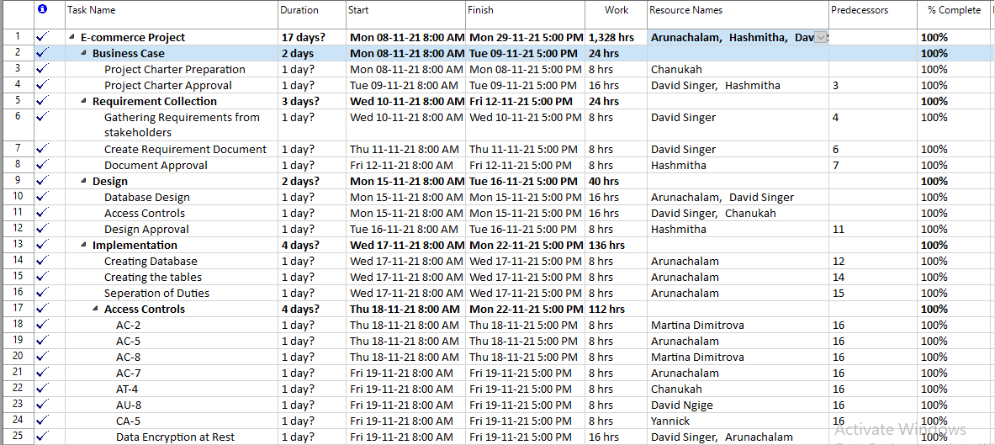

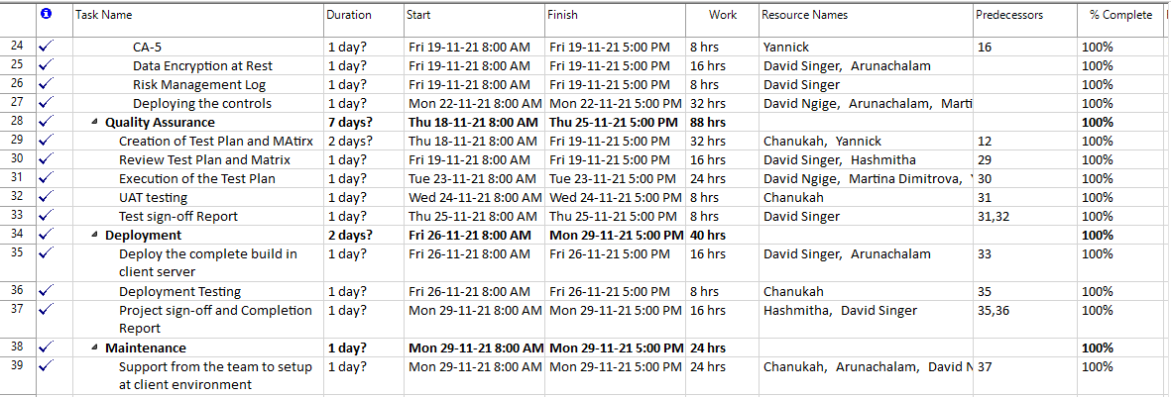

# Project Success Criteria

See project charter.

# Communication Management Plan

Below are the team members and the meeting schedules during which the team met to discuss the requirement, clarification, and completion of the project.

|  |  |
| --- | --- |
| **Name** | **Role** |
| Arun | DBA |
| Martina | Developer |
| Arun | DBA |
| Martina | Developer |
| Arun | DBA |
| Chanukah | Developer |
| David N. | Developer |
| Yannick | Developer |
| Chanukah/ Hashmitha | S. Developer/Project Manager |
| Arun/ David S. | DBA/Developer |
| David S. | Project Leader |
| Chanukah/ Hashmitha | S. Developer/Project Manager |

**Meetings Scheduled:**

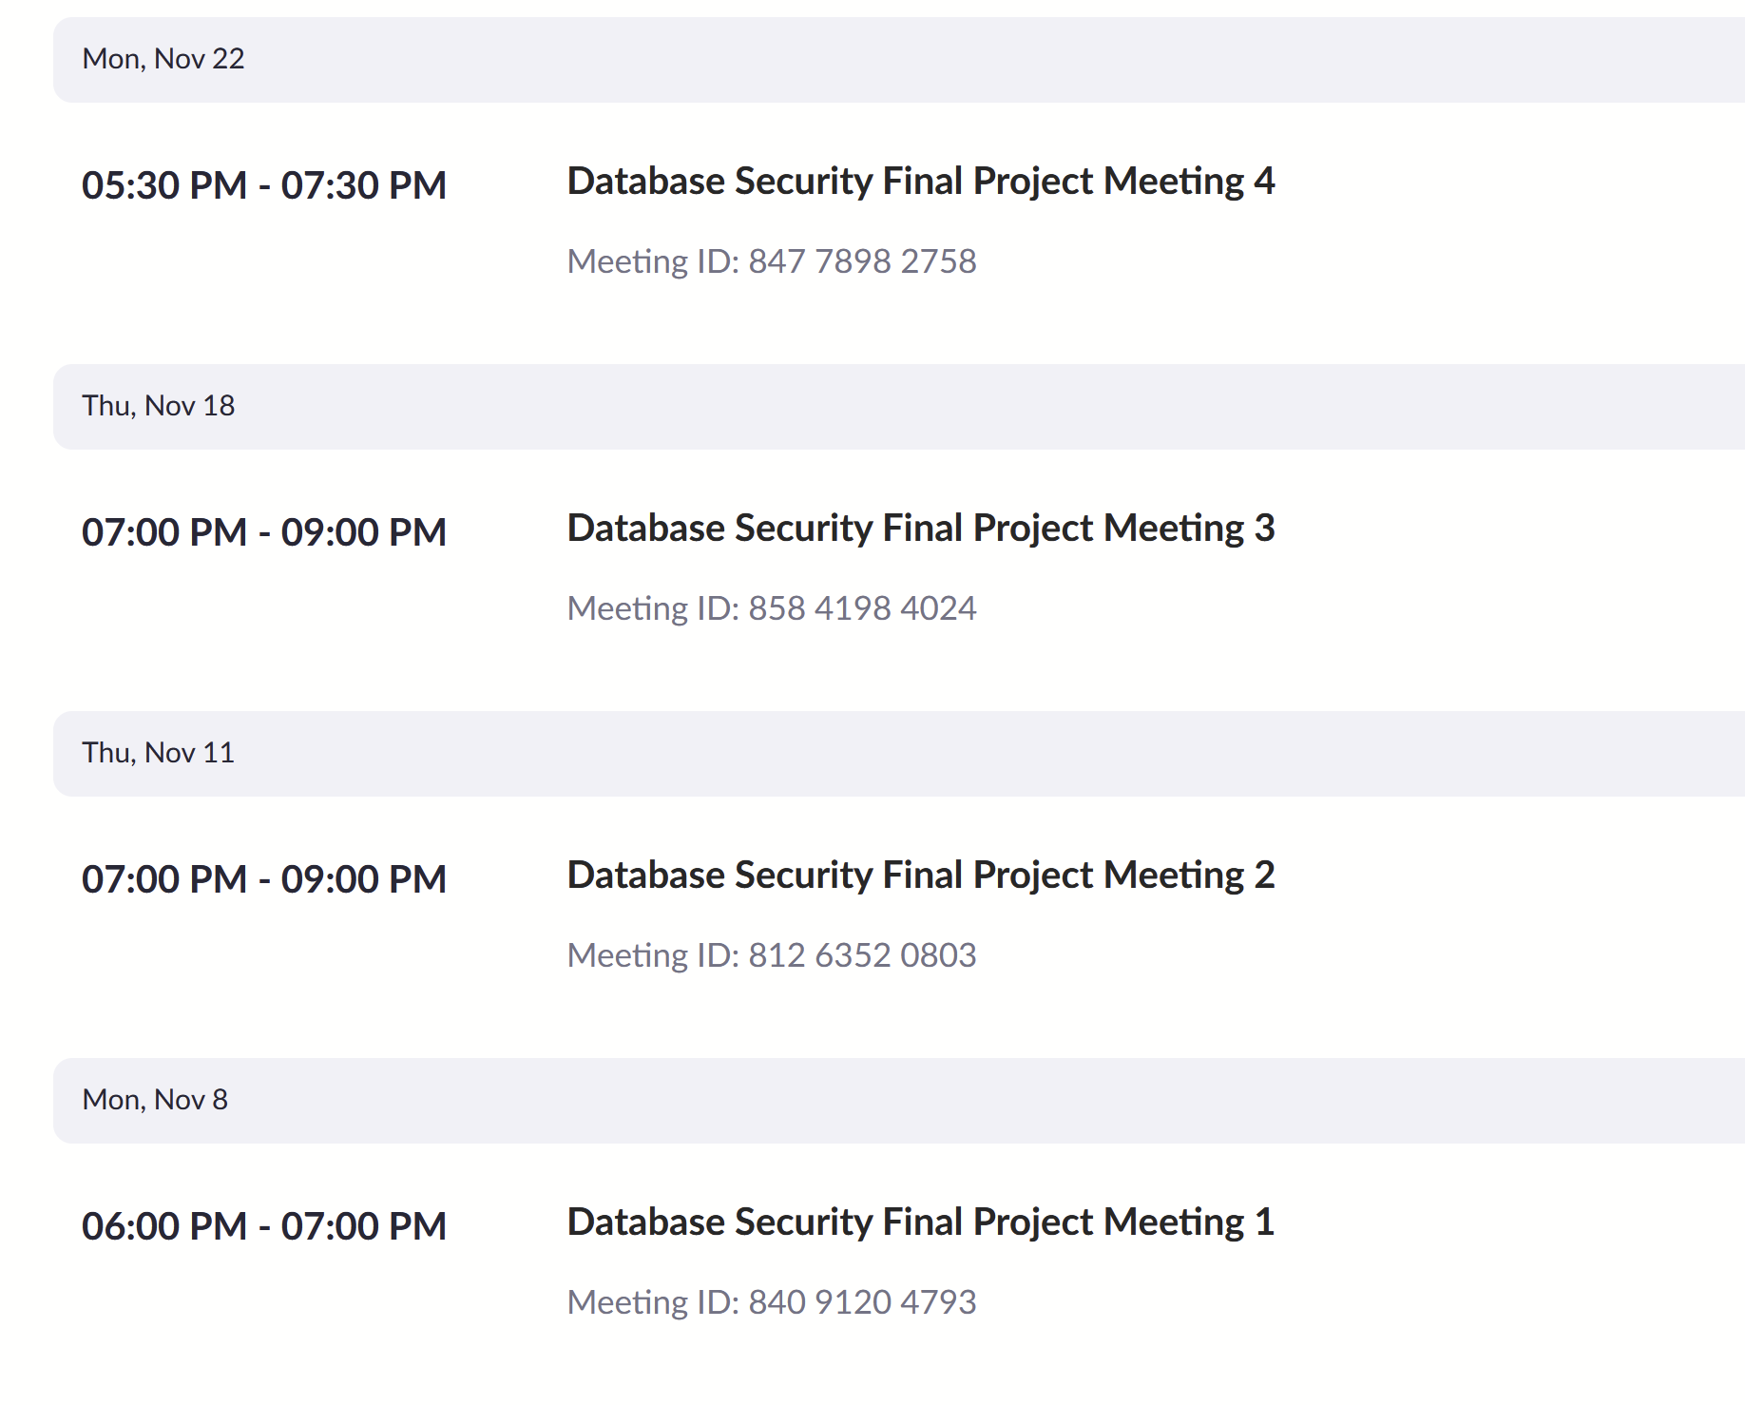

# Risk Management Plan

See Risk Management Log.

# Software Configuration Management (SCM) Plan

See the software configuration management plan.

# Training Plan

The training plan will be developed during the planning and active stages of the project. We are planning to train all the team members to have knowledge about the software and access controls that are to be applied on to a database. Since we follow Agile Methodology, our team members will be working simultaneously on quality assurance as well.

# Quality Assurance Plan

Any systematic process of verifying whether a product or service fulfills defined requirements is known as quality assurance (QA).

Set requirements for designing or manufacturing dependable products are established and maintained by QA. A quality assurance system is designed to boost consumer trust and credibility while also enhancing work procedures and efficiency, allowing a company to compete more effectively.

For the test plan see Project Schedule.

# Project Measurement Plan

This project is not tracked in PMAS.

## Description

Project Measurement Plan for the E-Commerce Project focuses on implementing the seven NIST special publication 800-53 controls. Therefore the metrics for the project will be in place to ensure controls are executed as planned. The metrics are:

* Compliance with account management requirements and change control
* Separation of duties control failure
* System use notification up time
* Unsuccessful Login attempt control failure
* Security training completion rate
* Missed time stamps
* Completion rate of the actions and milestones

Data collection for these 7 KPIs would be done through system reporting and tracked on a weekly basis in a central MySQL database where the reporting of the measurements will be done on a monthly basis. We plan to use MS Excel to do the data analysis and KPI reporting for the stakeholders.

## Performance Measurements

**Table 5: E-Commerce Project** **Performance Measurements**

|  |  |  |  |
| --- | --- | --- | --- |
| **No.** | **Measurement Name** | **Measurement Objective** | **Metric** |
| 1. | Compliance with account management requirements and change control | Ensuring that process controls for account management and user removal are being followed | 100% | **Definition:** 1- (Number of control misses/ Total number of account management and user removal attempts) |
| 2. | Separation of duties control failure | Making sure that security personnel installing access control, does not have access to audit functions | 100% | **Definition:** 1- (Number of control misses/ Total number of active users) |
| 3. | System use notification up time | Display message up time before granting access to the system based on requirements set. | 99% | **Definition:** 1- (Number of times the display message failed/ Total number of times the message to be displayed) |
| 4. | Unsuccessful Login attempt control failure | System to be locked down for a defined period of time after a predetermined number of attempts | 100% | **Definition:** 1- (Number of control misses/ Total number of unsuccessful login attempts) |
| 5. | Security training completion rate | For all users to complete the training on time | 100% | **Definition:** 1- (Number of users didn’t complete the training/ Total number of active users) |
| 6. | Missed time stamps | Every activity to have a system time stamp | 100% | **Definition:** 1- (Number of time stamps missed/ Total number of time stamp opportunities) |
| 7. | Completion rate of the actions and milestones | All actions taken to be completed along with the predefined milestones | 100% | **Definition:** 1- (Number of actions and milestones missed/ Total number of actions and milestones) |

# Reference Materials

**AT- 4 Security Training Logs**

https://csrc.nist.gov/Projects/risk-management/sp800-53-controls/release-search#!/control?version=5.1&number=AT-4

https://19january2017snapshot.epa.gov/sites/production/files/2016-01/documents/cio_2150-p-02.2.pdf

https://exceldatapro.com/employee-training-log/

https://public.cyber.mil/cyber-training/training-catalog/?_training_types=online-training

**AU-8 Time Stamping**

https://csf.tools/reference/nist-sp-800-53/r4/au/au-8/au-8-1/

https://dev.mysql.com/doc/refman/8.0/en/time-zone-support.html

https://dev.mysql.com/doc/refman/8.0/en/date-and-time-functions.html

**Project Management**

https://www.pmi.org/learning/library/earned-value-management-systems-analysis-8026

https://www.wikihow.com/Develop-a-Risk-Management-Plan

https://www.fhwa.dot.gov/majorprojects/pmp/pmp_guide_jan09.pdf**Approval Signatures**

PAO has additional approver language:

# Project Plan Approval

The signatures below indicate that the undersigned:

* Have reviewed the Project Plan.
* Have formally voiced applicable concerns to the PM.
* Concur that the Project Plan accurately represents their expectations and conditions required for the project.
* Are committed to providing the required resources.
* Are unaware of undocumented conditions that prevent the success of this project.

REVIEW DATE: *11/29/2021*

SCRIBE: Chanukah

Signed: [Hashmitha Shantharam](mailto:hshantharam@hawk.iit.edu) 11/29/2021

_____________________________________________________________________

Project Manager Date

Signed: ______________________________________________________________________

Business Sponsor Date

**Template Revision History**

|  |  |  |  |
| --- | --- | --- | --- |
| **Date** | **Version** | **Description** | **Author** |
| November 29, 2021 | 1.3 | Final Version | Hashmitha Shantharam |
| November 27, 2021 | 1.2 | Added references, Add performance measurements, updated the project charter and project success criteria. | Chanukah Wijeratne |
| November 9, 2021 | 1.1 | Initial Version | Hashmitha Shantharam |